Test Case: tc005_SPX_Dev5_Crear_Requisicion_Spot_Con_FAD_Tipo_Cobro_Project
Step 1 - Enter username and password and click to button Enter: Credentials Entered
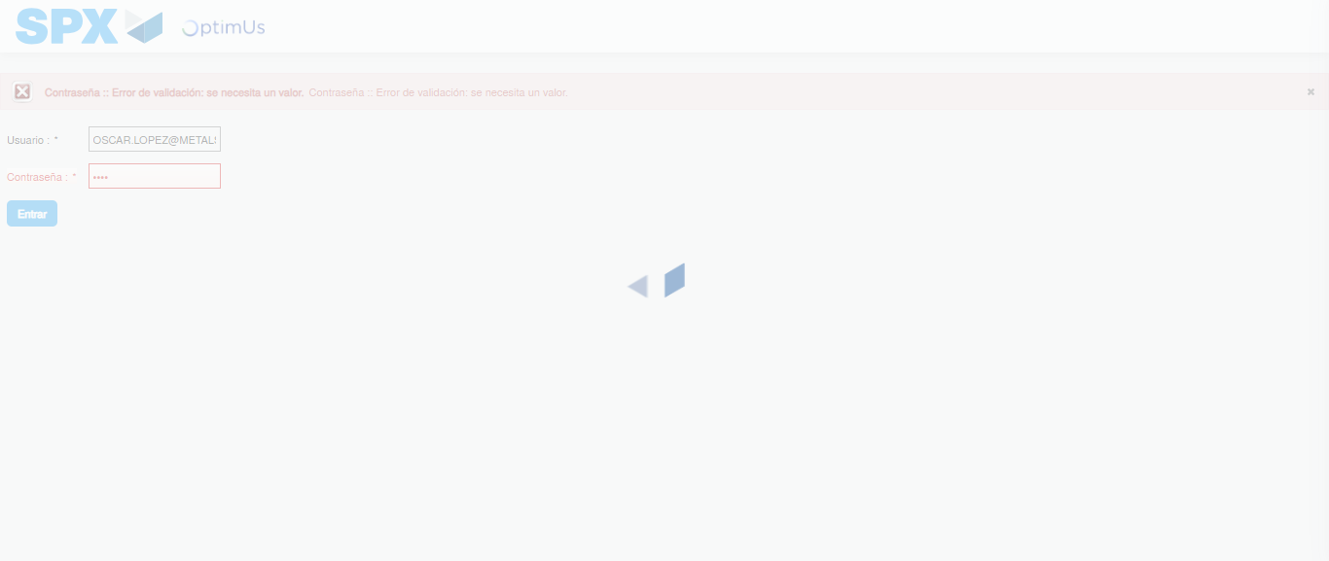Image file-name: QC_Testing-tc005_SPX_Dev5_Crear_Requisicion_Spot_Con_FAD_Tipo_Cobro_Project-1784573291112

Step 2 - Select to UEN and Access to Spot Buy Requisitions : UEN Correctly selected and Correct access
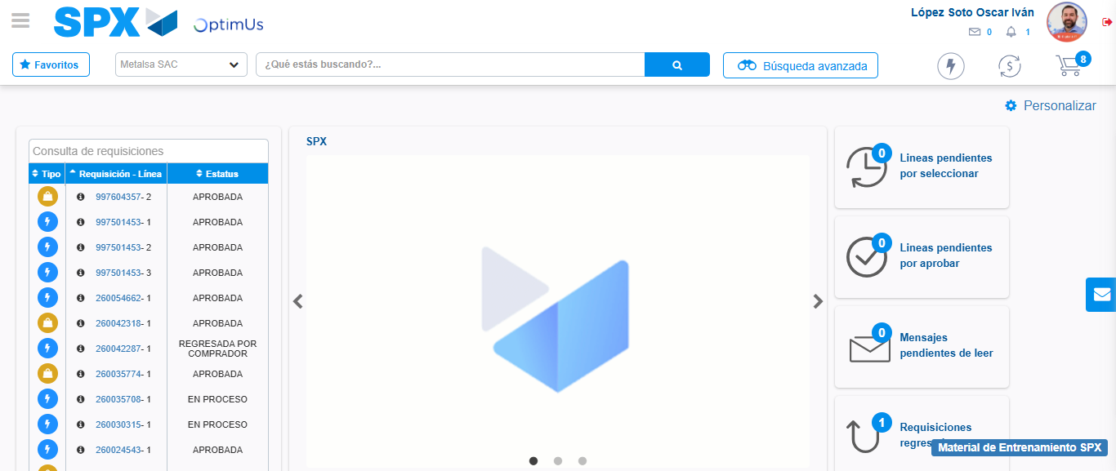Image file-name: QC_Testing-tc005_SPX_Dev5_Crear_Requisicion_Spot_Con_FAD_Tipo_Cobro_Project-1784573360813

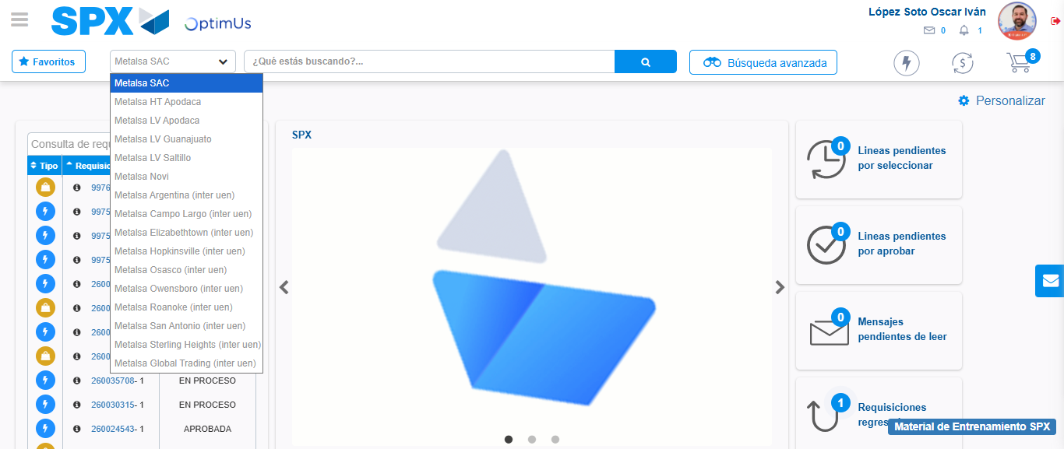Image file-name: QC_Testing-tc005_SPX_Dev5_Crear_Requisicion_Spot_Con_FAD_Tipo_Cobro_Project-1784573363423

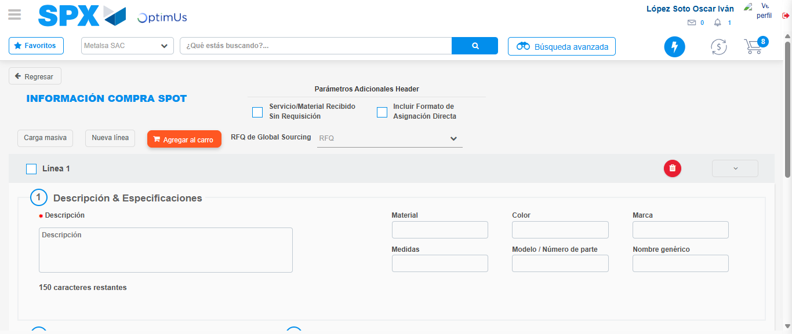Image file-name: QC_Testing-tc005_SPX_Dev5_Crear_Requisicion_Spot_Con_FAD_Tipo_Cobro_Project-1784573380868

Step 3 - Add FAD to Requisition: FAD Successfully Added
Image file-name: QC_Testing-tc005_SPX_Dev5_Crear_Requisicion_Spot_Con_FAD_Tipo_Cobro_Project-1784573381110

Image file-name: QC_Testing-tc005_SPX_Dev5_Crear_Requisicion_Spot_Con_FAD_Tipo_Cobro_Project-1784573381279

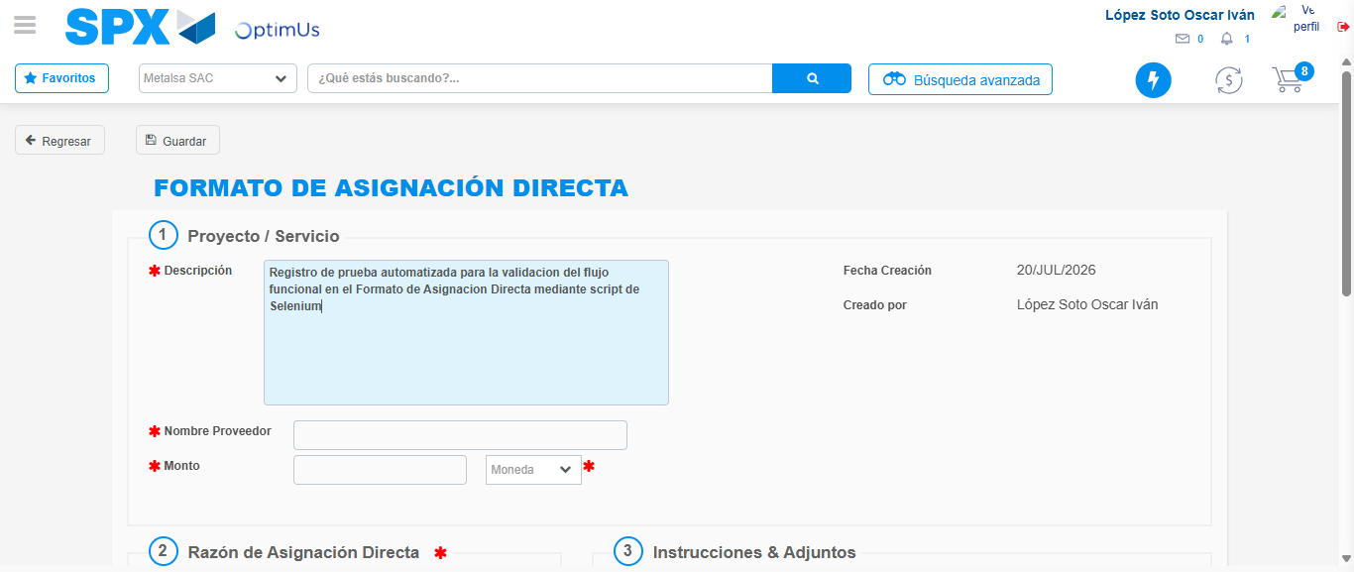Image file-name: QC_Testing-tc005_SPX_Dev5_Crear_Requisicion_Spot_Con_FAD_Tipo_Cobro_Project-1784573384095

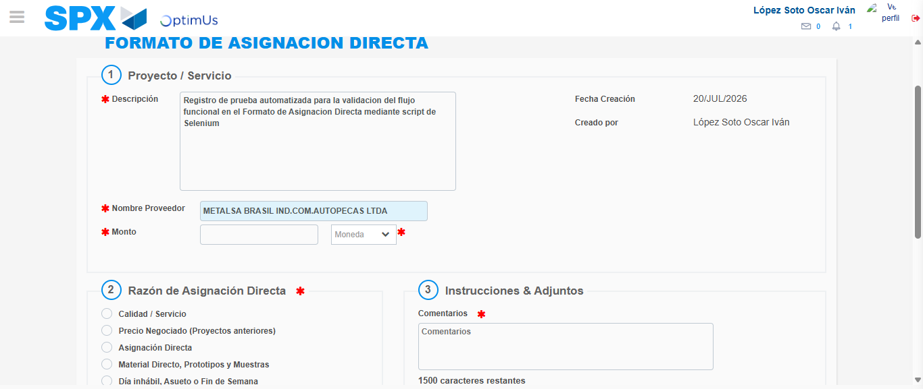Image file-name: QC_Testing-tc005_SPX_Dev5_Crear_Requisicion_Spot_Con_FAD_Tipo_Cobro_Project-1784573390313

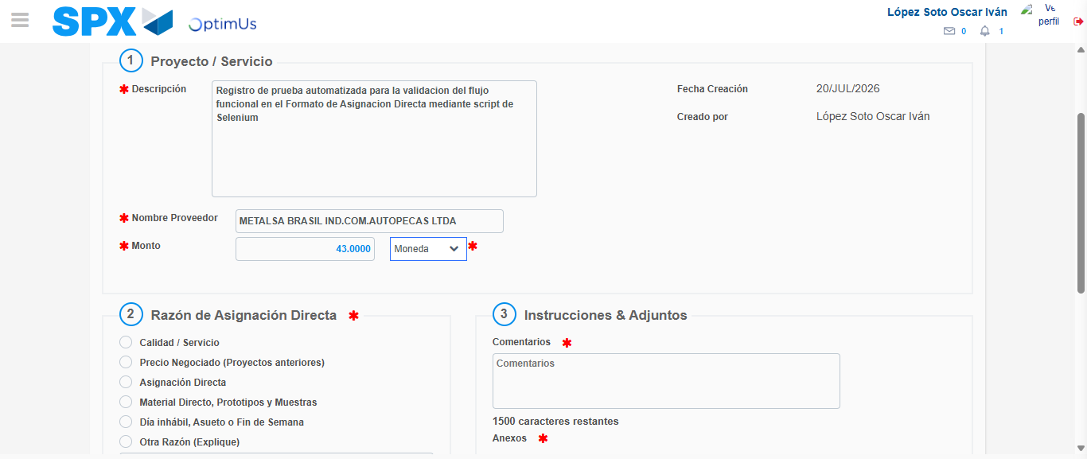Image file-name: QC_Testing-tc005_SPX_Dev5_Crear_Requisicion_Spot_Con_FAD_Tipo_Cobro_Project-1784573390746

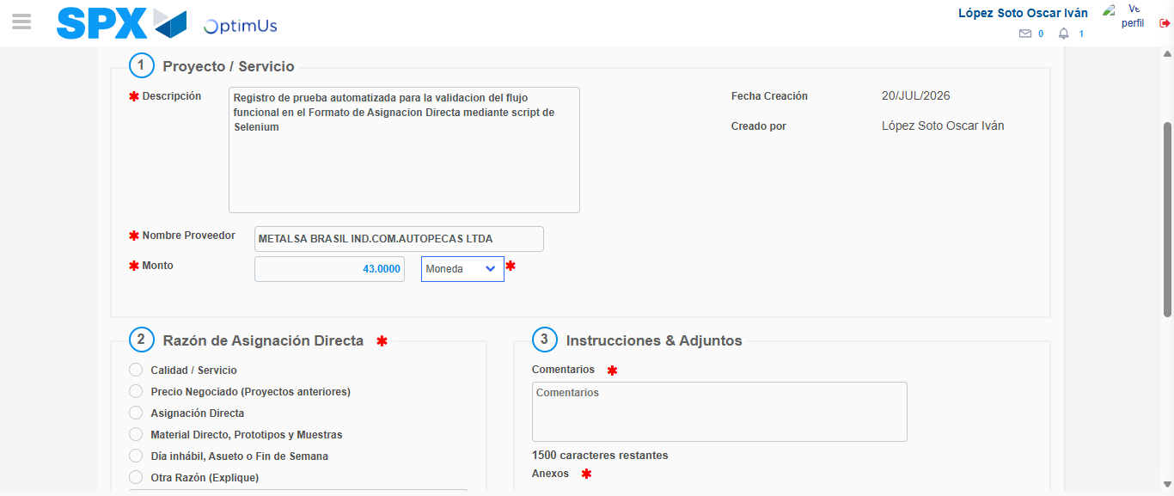Image file-name: QC_Testing-tc005_SPX_Dev5_Crear_Requisicion_Spot_Con_FAD_Tipo_Cobro_Project-1784573390959

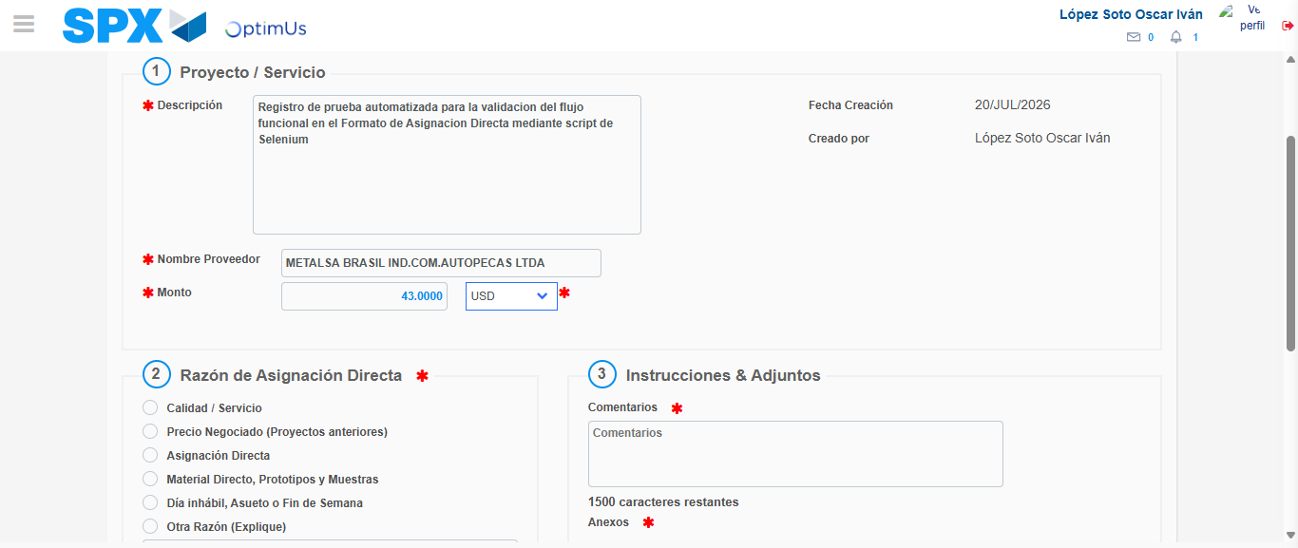Image file-name: QC_Testing-tc005_SPX_Dev5_Crear_Requisicion_Spot_Con_FAD_Tipo_Cobro_Project-1784573391365

Image file-name: QC_Testing-tc005_SPX_Dev5_Crear_Requisicion_Spot_Con_FAD_Tipo_Cobro_Project-1784573391558

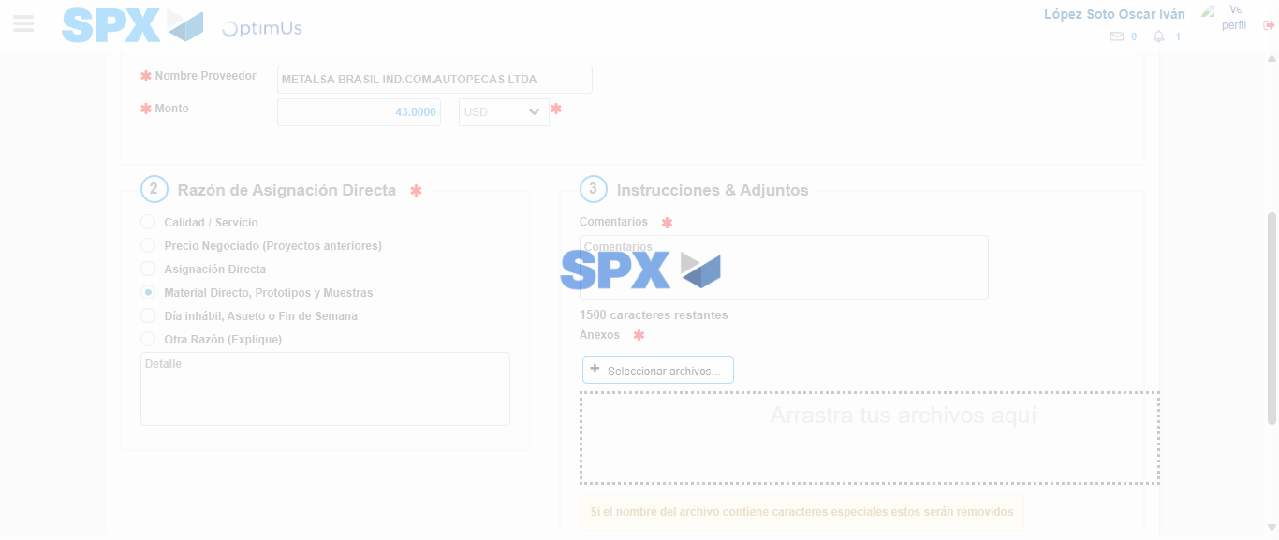Image file-name: QC_Testing-tc005_SPX_Dev5_Crear_Requisicion_Spot_Con_FAD_Tipo_Cobro_Project-1784573392391

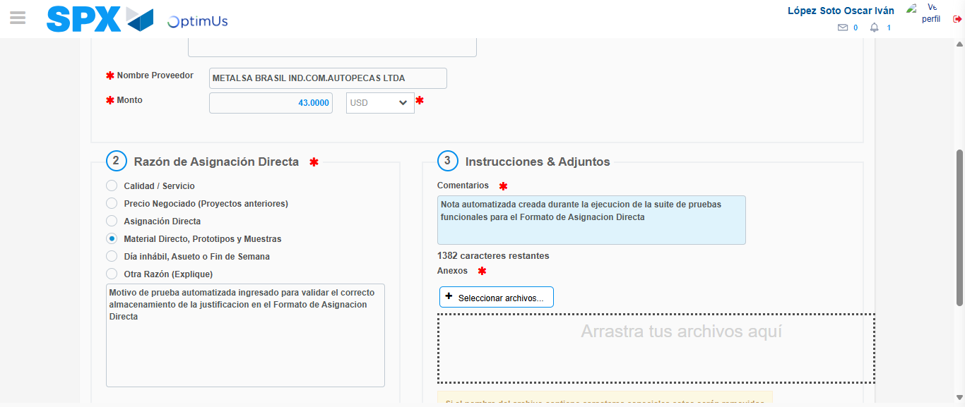Image file-name: QC_Testing-tc005_SPX_Dev5_Crear_Requisicion_Spot_Con_FAD_Tipo_Cobro_Project-1784573403343

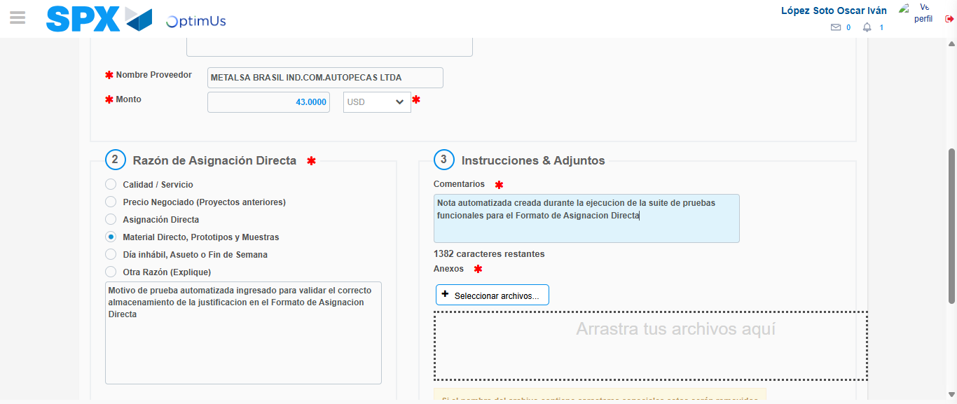Image file-name: QC_Testing-tc005_SPX_Dev5_Crear_Requisicion_Spot_Con_FAD_Tipo_Cobro_Project-1784573403999

Step 4 - Data Capture Spot Buy Requisition: Data captured correctly
Image file-name: QC_Testing-tc005_SPX_Dev5_Crear_Requisicion_Spot_Con_FAD_Tipo_Cobro_Project-1784573381110

Image file-name: QC_Testing-tc005_SPX_Dev5_Crear_Requisicion_Spot_Con_FAD_Tipo_Cobro_Project-1784573381279

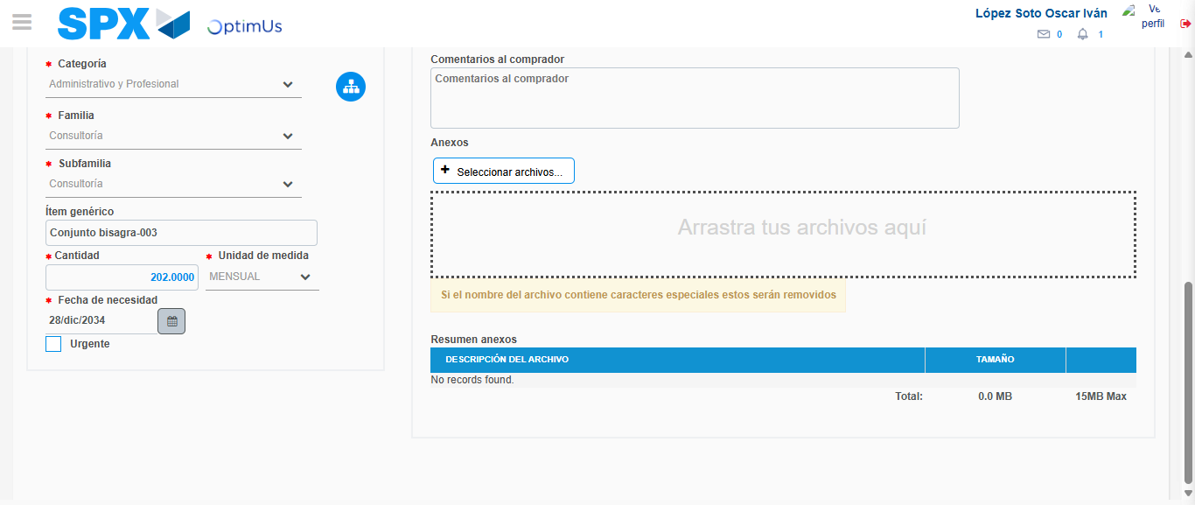Image file-name: QC_Testing-tc005_SPX_Dev5_Crear_Requisicion_Spot_Con_FAD_Tipo_Cobro_Project-1784573417262

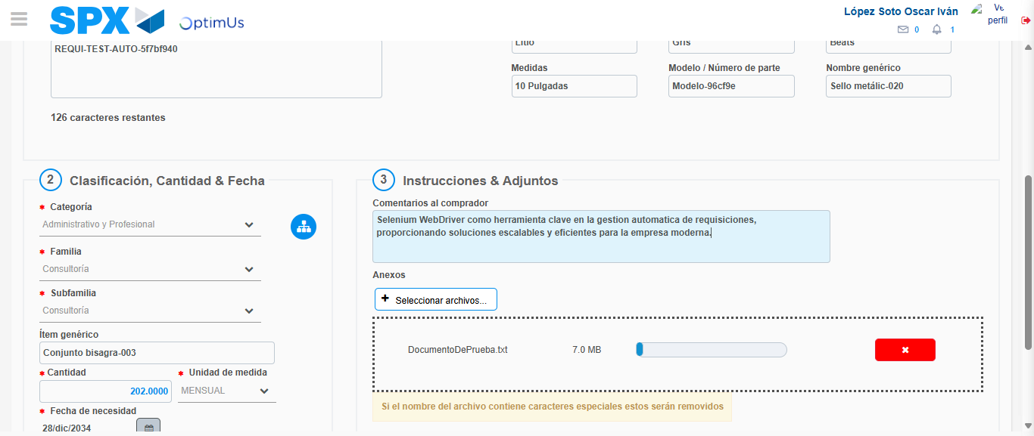Image file-name: QC_Testing-tc005_SPX_Dev5_Crear_Requisicion_Spot_Con_FAD_Tipo_Cobro_Project-1784573418014

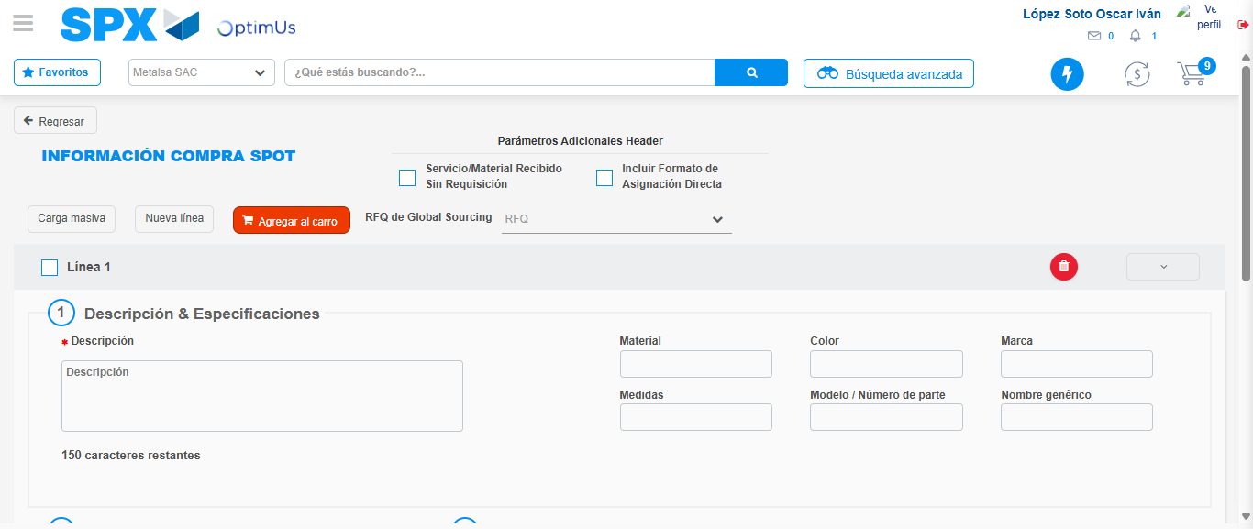Image file-name: QC_Testing-tc005_SPX_Dev5_Crear_Requisicion_Spot_Con_FAD_Tipo_Cobro_Project-1784573426928

Step 8 - Return to Main Page SPX : Return to Main Page SPX
Image file-name: QC_Testing-tc005_SPX_Dev5_Crear_Requisicion_Spot_Con_FAD_Tipo_Cobro_Project-1784573360813

Image file-name: QC_Testing-tc005_SPX_Dev5_Crear_Requisicion_Spot_Con_FAD_Tipo_Cobro_Project-1784573363423

Image file-name: QC_Testing-tc005_SPX_Dev5_Crear_Requisicion_Spot_Con_FAD_Tipo_Cobro_Project-1784573380868

Image file-name: QC_Testing-tc005_SPX_Dev5_Crear_Requisicion_Spot_Con_FAD_Tipo_Cobro_Project-1784573429137

Image file-name: QC_Testing-tc005_SPX_Dev5_Crear_Requisicion_Spot_Con_FAD_Tipo_Cobro_Project-1784573429303

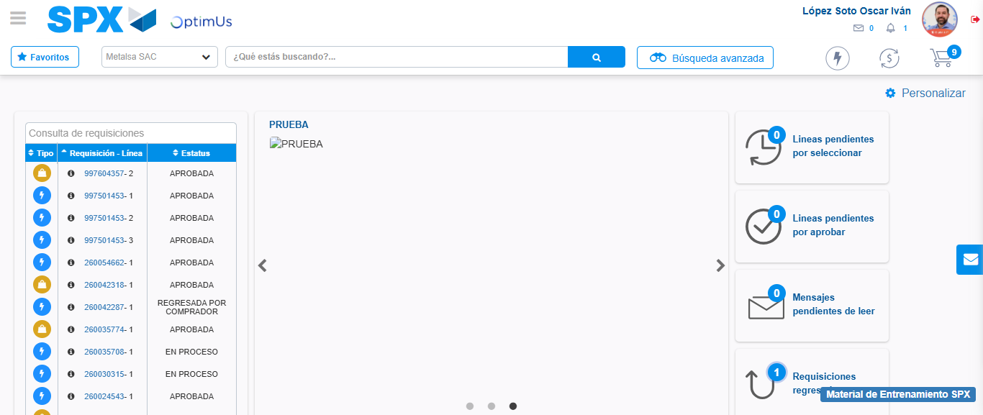Image file-name: QC_Testing-tc005_SPX_Dev5_Crear_Requisicion_Spot_Con_FAD_Tipo_Cobro_Project-1784573450349

Step 9 - Log Out : Log Out SPX
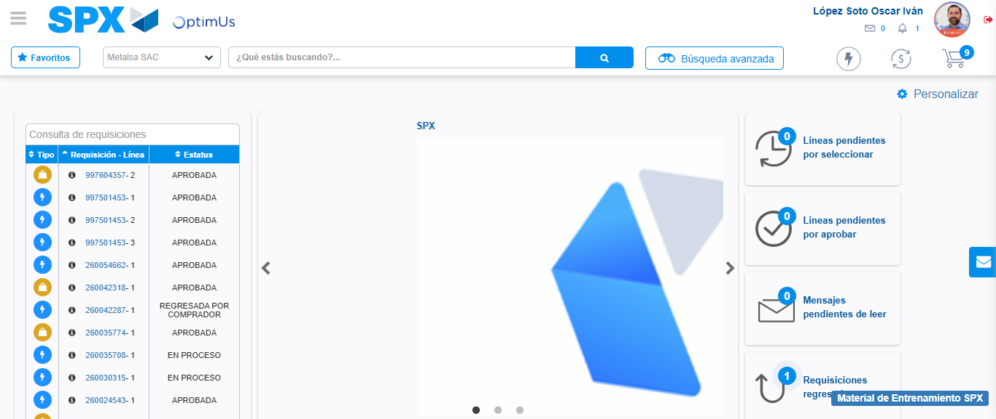Image file-name: QC_Testing-tc005_SPX_Dev5_Crear_Requisicion_Spot_Con_FAD_Tipo_Cobro_Project-1784573450658

